Turning Off Your Home's Natural Gas

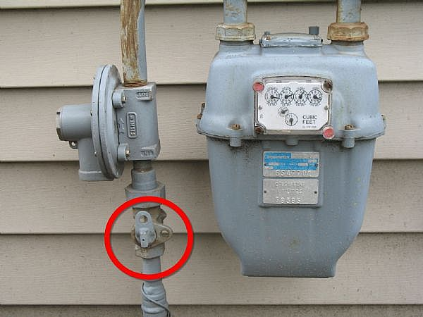 | WHERE: Locate your gas meter. In Utah, gas meters are usually located above ground on the outside of your house. It's important to know exactly where your natural gas meter is so you can find it in case of an emergency.
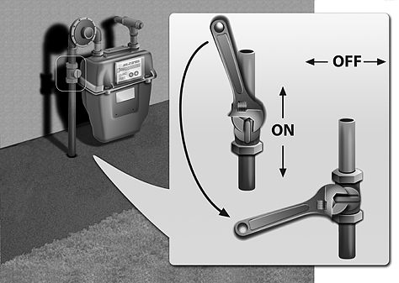 | HOW: Near the meter a pipe runs from the ground to the meter. There should be a shut-off valve in-line with that pipe, several inches above the ground. Using an adjustable wrench or gas wrench, turn the valve 1/4 turn in either direction, until the valve is crosswise to the pipe. Tip: Keep a gas wrench or an adjustable wrench with your emergency kit, or near your gas valve. A $5 gas wrench can be purchased at an emergency-supply store.
CAUTION: If you turn off your natural gas at the meter, leave it off. Contact the gas company to turn the meter back on and re-light the pilots. | WHEN: Only shut off your gas if you smell gas, hear gas escaping, see a broken gas line or suspect a gas leak. Once the gas is shut off at the meter, do not turn it back on. Dominion Energy or another qualified professional should perform a safety inspection before the gas service is restored and the appliance pilots are lit.

Turning Off Your Home's Water

 | WHERE: Locate your home's water shutoff valve. In Utah homes with basements, this valve is usually located on the front-facing concrete wall of your basement. Newer homes generally use ball valves, but older homes may have either type. The valve may be concealed behind a panel or in a closet, so it's important to know where your shutoff valve is so you can find it in an emergency.
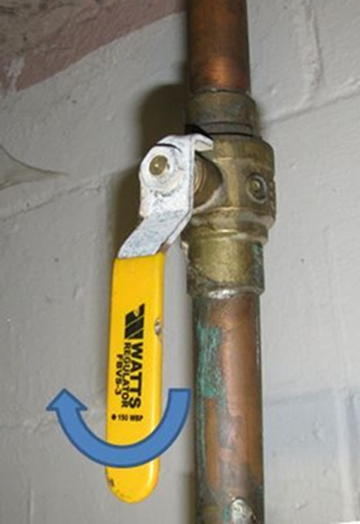 | HOW: If you have a ball valve: Use your hand to turn the valve handle 1/4 turn. The water is off when the valve is crosswise to the pipe.  If you have a gate valve: Use your hand to turn the valve handle clockwise until the valve is fully closed. Sometimes gate valves get stuck and become difficult to turn.
NOTE: You may turn your house water back on whenever you feel it is safe to do so. | WHEN: Shut off your water if you discover water leaks in your house or if you believe the city water is contaminated and you want to preserve the water stored in your water heaters, toilet tanks, etc. for drinking and cooking.

Source: from 2018 Stonewood Stake Emergency Preparedness Resources

